Migration from QC to Jama

# 1. User Needs (UN)

## 1.1 Export UN from QC

Login QC and select Domain and Project. Enter Analysis View -> Public -> Requirements -> QC_UserNeeds. Click Generate to generate **QC_UserNeeds.xlsx** (*Figure 1.1*).

*Figure 1.1: QC generate UN*

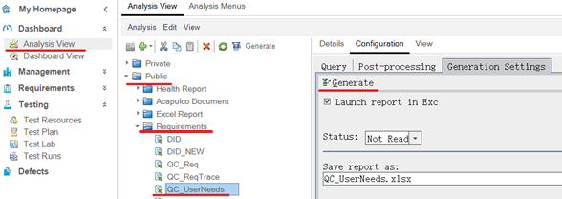

## 1.2 Import UN into Jama

1. Login Jama. Select project and set (add a new set as needed).
2. Right click on the set and select Import. Choose **QC_UserNeeds.xlsx** in Import dialog. Click Next.
3. Select sheet Query1. Set “Default Value” and “Mapping” following *Figure 1.2.1*, and click Next.

*Figure 1.2.1: Data Import Wizard-Field Mapping*

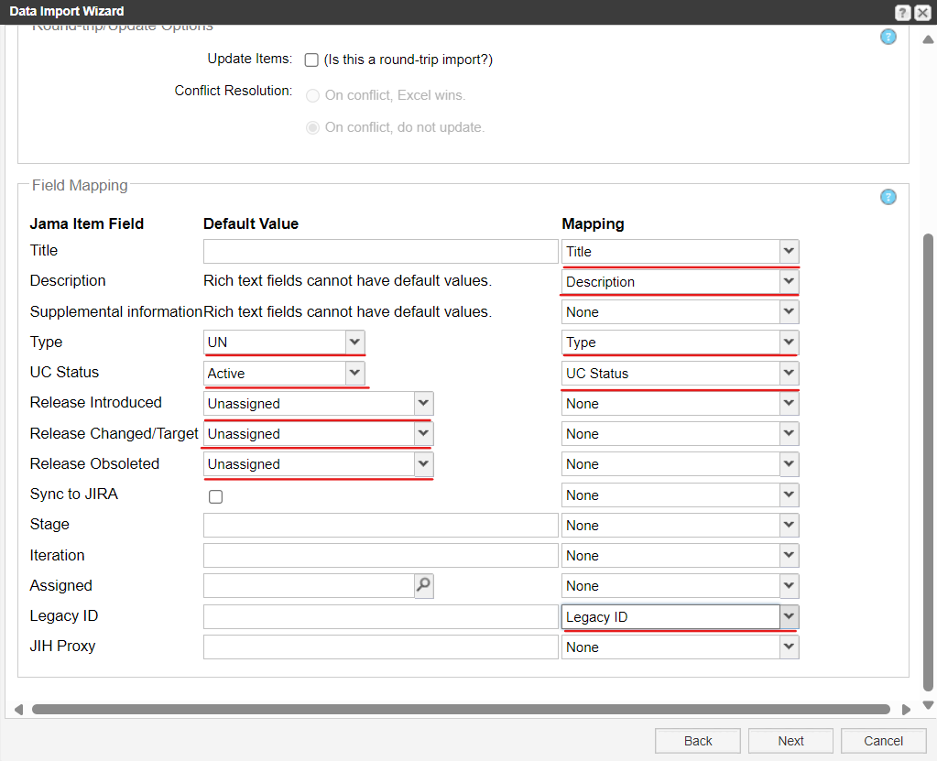

1. Click Next in **Additional Options** following *Figure 1.2.2***.**

*Figure 1.2.2: Data Import Wizard – Additional Options*

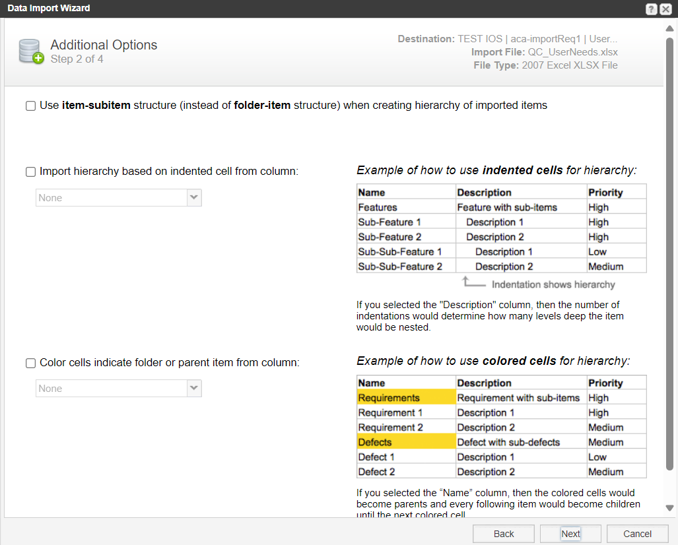

1. Click Submit to finish import.

# 2. Design Input Requirements (DI)

## 2.1 Export DI from QC

Login QC and select domain and project. Enter Analysis View -> Public -> Requirements -> QC_Req. Click Generate. ***QC_Req.xlsx*** is generated.

## 2.2 Set hierarchy of DI in Excel

1. Make sure the exported file ***QC_Req.xlsx*** is closed.
2. Config **DI_Set_Hierarchy** section in ***migrate_Jama_QC.json***. Only need to set correct path of ***QC_Req.xlsx*** for the argument of QC_Req_Path. No need to change other arguments in the file. Refer to *Figure 2.1*.

*Figure 2.1: Json Config*

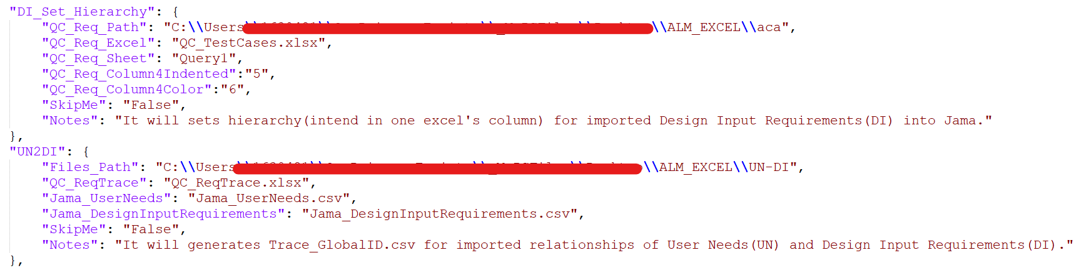

1. Run “***1_QC_Req_Set_Hierarchy.bat***” and wait it finished. Open ***QC_Req.xlsx***, and check if column 5 named “Release Introduced” is formatted with Indent which indicates the hierarchy of DI, and check if column 6 named “REQ Status” is formatted with yellow color which indicates the hierarchy of DI.

## 2.3 Import DI into Jama

1. Login Jama. Select project and set (add a new set as needed). Right click on the set and select Import. Choose ***QC_Req.xlsx*** in Import dialog. Click Next.
2. Select sheet Query1. Set “Default Value” and “Mapping” following *Figure 2.2*. Click Next.

*Figure 2.2: Data Import Wizard-Field Mapping*

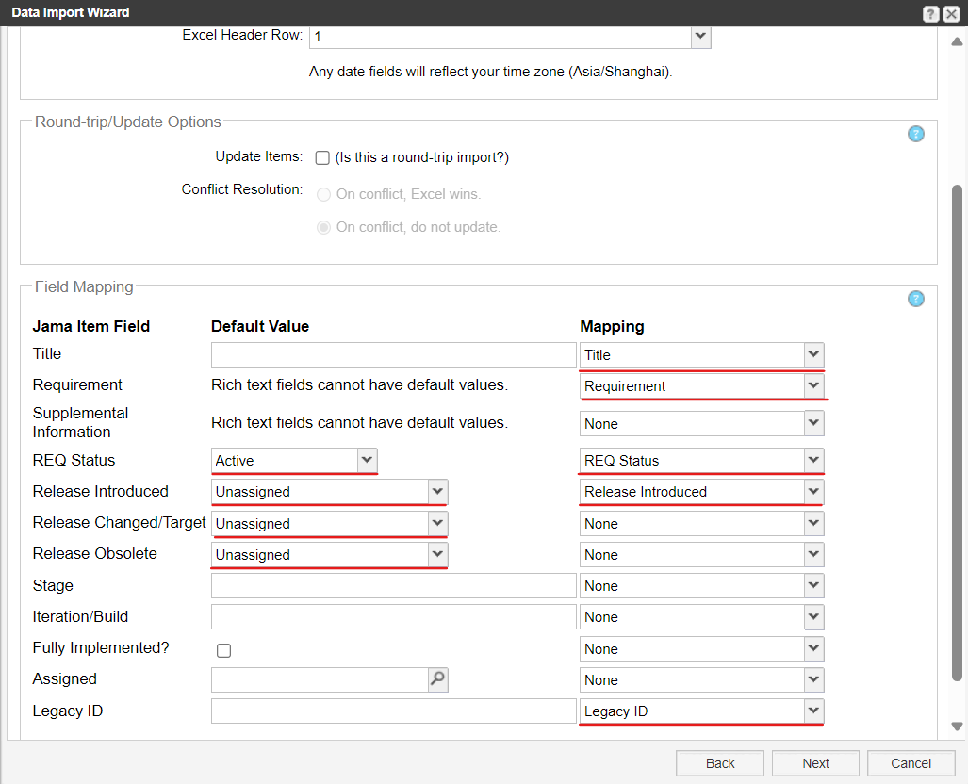

1. Check “Import hierarchy based on indented cell from column” and select “Release Introduced” field, and Check “Color cells indicate folder or parent item from column” and select “REQ Status” field following *Figure 2.3*. Click Next.

*Figure 2.3: Data Import Wizard – Additional Options*

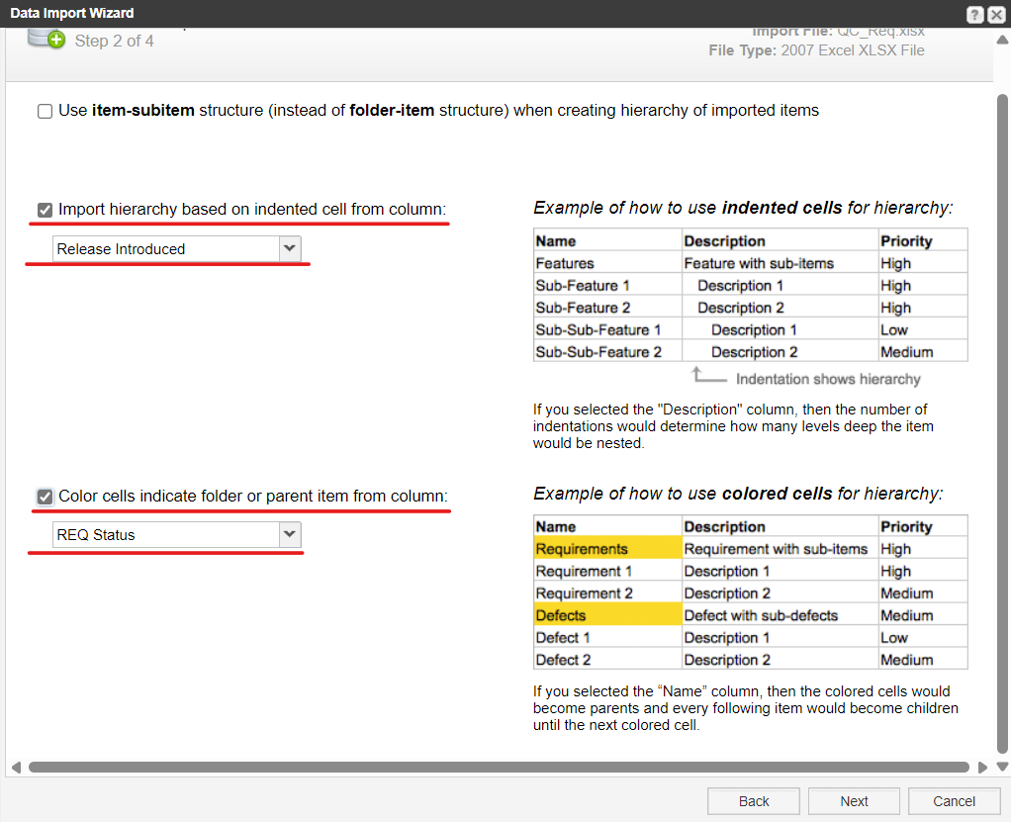

1. Click Submit for finished import.

# 3. Relationship between User Needs (UN) and Design Inputs (DI)

## 3.1 Export trace view (.csv) of UN from Jama

1. Login Jama, enter User Needs -> Trace View.

*Figure 3.1.1: User Needs Trace view*

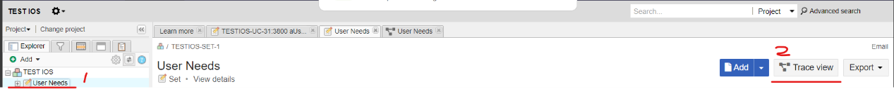

1. Click “Set columns” in “SOURCE ITEMS”. Select Project ID, Global ID, Legacy ID, and deselect others.

*Figure 3.1.2: Settings in Trace view*

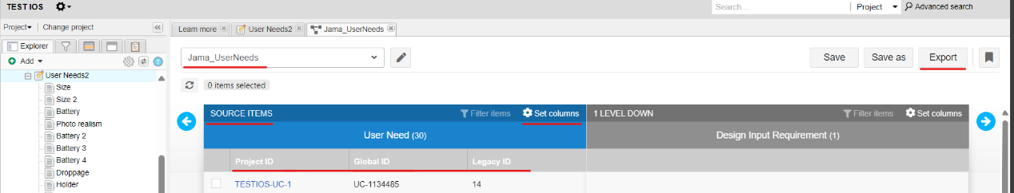

1. Click “Set columns” in “1 LEVEL DOWN”. Deselect all.
2. Click Save. Modify the name of the saved trace view to “Jama_UserNeeds” (Figure 3.2). Click Export.
3. The file **Jama_UserNeeds.csv** is generated as *Figure 3.1.3*.

*Figure 3.1.3: Jama_UserNeeds.csv*

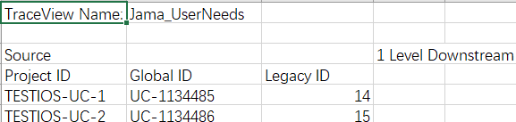

## 3.2 Export trace view (.csv) of DI from Jama

1. Login Jama, enter Design Input Requirements -> Trace View.
2. Click “Set columns” in “SOURCE ITEMS”. Select Project ID, Global ID, Legacy ID, and deselect others.

*Figure 3.2: Design Input Requirements Trace view*

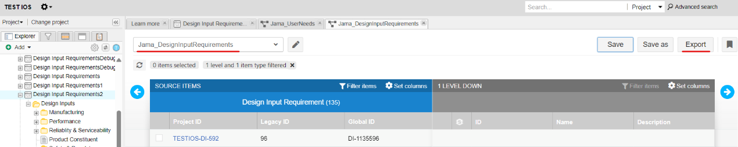

1. Click “Set columns” in “1 LEVEL DOWN”. Deselect all.
2. Click Save. Modify the name of the saved trace view to “Jama_DesignInputRequirements” (*Figure 3.2*). Click Export.
3. The file ***Jama_DesignInputRequirements.csv*** is generated with similar format in *Figure 3.3*.

## 3.3 Export Legacy ID trace of UN2DI from QC

Login QC and select domain and project. Enter Analysis View -> Public -> Requirements -> QC_ReqTrace. Click Generate. The file ***QC_ReqTrace.xlsx*** is generated as *Figure 3.3*.

*Figure 3.3: QC_ReqTrace.xlsx*

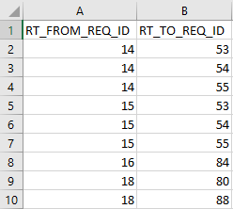

## 3.4 Create Global ID trace of UN2DI

1. Make sure the exported files (*QC_ReqTrace.xlsx, Jama_DesignInputRequirements.csv, Jama_UserNeeds.csv*) are put to the same path and all closed.
2. Config UN2DI section in migrate_Jama_QC.json (*Figure 2.1*). Only need to set correct file path for the argument of Files_Path. No need to change other arguments in the file.
3. Run “***2_Jama_Trace_UN2DI.bat***” to generate the files ***Trace_UN2DI_GlobalID.csv*** and ***Trace_UN2DI_Verify.csv***. ***Trace_UN2DI_Verify.csv*** is useful for checking internal result with Legacy ID.

*Figure 3.4.1: Trace_UN2DI_GlobalID.csv*

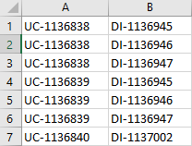

*Figure 3.4.2: Trace_UN2DI_Verify.csv*

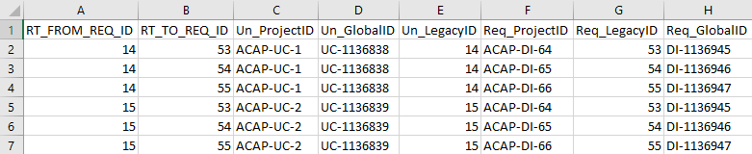

## 3.5 Import trace of UN2DI (by Global ID) to Jama

1. In Jama, select Project->Import->Custom import (*Figure 3.5.1*).

Figure 3.5.1: Custom import

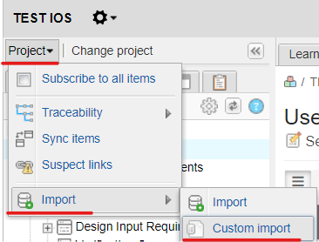

1. Select a set of User Needs as destination. Follow *Figure 3.5.2* to import by Global ID.
2. Verify the relationship as *Figure 3.5.3*.

Figure 3.5.2: Custom import-User Needs

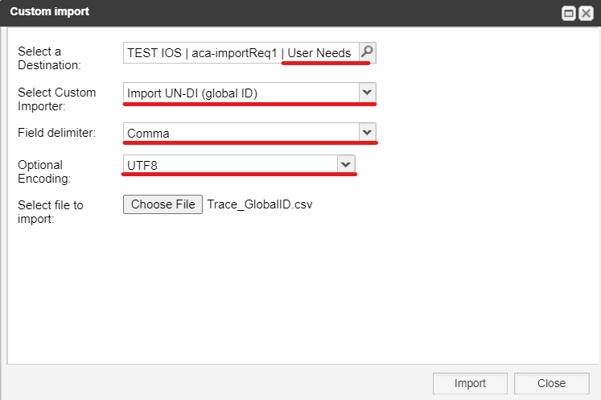

Figure 3.5.3: Verify relationships

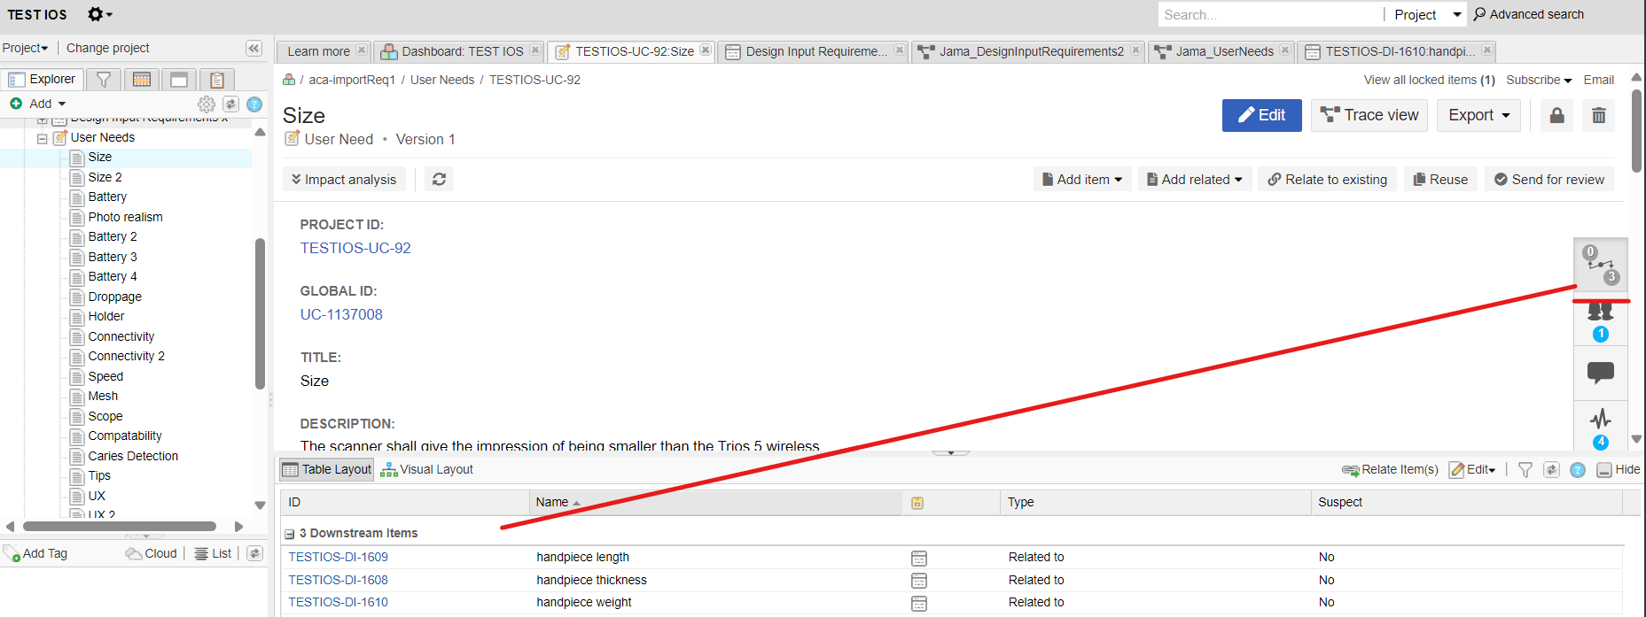

# 4. Test Cases(TC)

## 4.1 Export TC from QC

Login QC and select Domain and Project. Enter Analysis View -> Public -> Requirements -> **QC_TestCases**. Click Generate to generate ***QC_TestCases.xlsx*** (Figure 4.1.1, 4.1.2).

*Figure 4.1.1 QC-export TC*

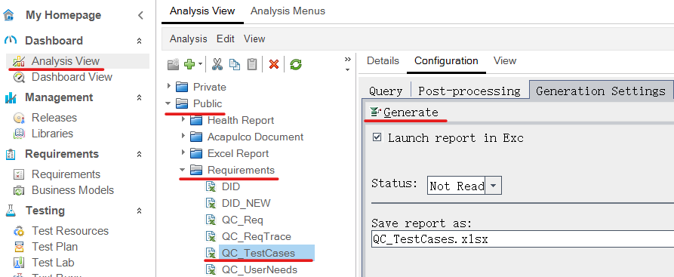

*Figure 4.1.2 QC-export TC-result*

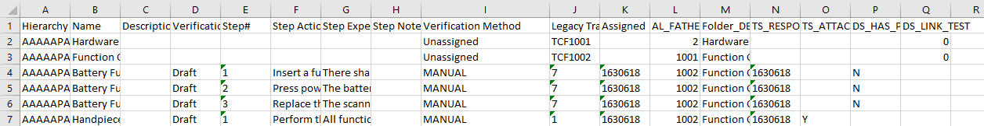

Notes:

* Column **Step Notes**: fill “HasAttachment” when one or more steps in this test case contain attachment, otherwise leave empty cell.
* Column **TS_ATTACHMENT**: fill “Y” when test case or step in this case contains attachment, otherwise leave empty cell or fill “N”.

## 4.2 Set hierarchy of TC in Excel

1. Make sure the exported file ***QC_*TestCases*.xlsx*** is closed.
2. Config **TC_Set_Hierarchy** section in ***migrate_Jama_QC.json***. Only need to set correct path of ***QC_TestCases.xlsx*** for the argument of *QC_TC_Path*. No need to change other arguments in the file. Refer to *Figure 4.2.1*.

*Figure 4.2.1 Json Config*

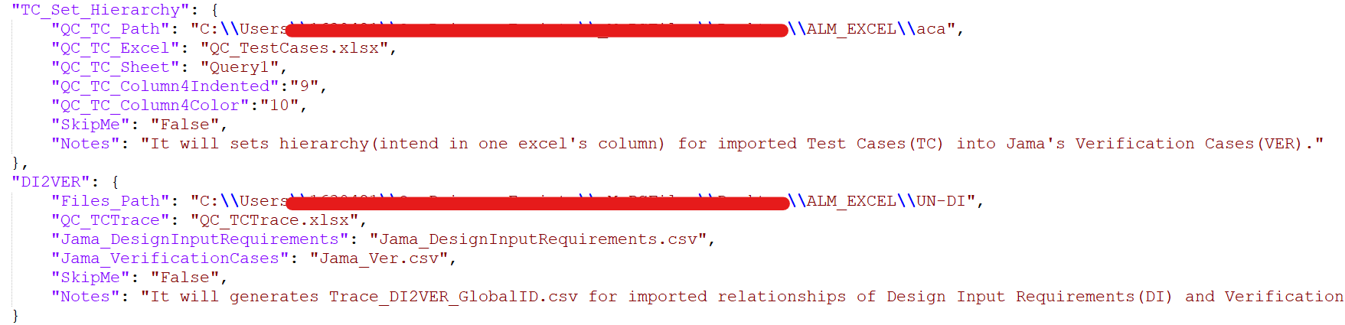

1. Double click ***3_QC_TC_Set_Hierarchy.bat*** to add format in ***QC_TestCases.xlsx***. Wait till finished.

*Figure 4.2.2 Format QC_TestCases.xlsx*

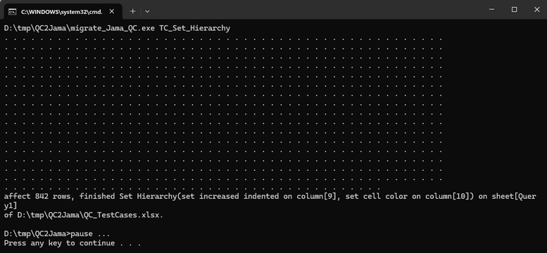

Note: One dot output to the console means one row in the Excel is handled (include the title row).

1. Open ***QC_TestCases.xlsx*** and check if column 9 named “Verification Method” is formatted with Indent which indicates the hierarchy of Verification Cases(VER) in Jama.

*Figure 4.2.3 Formatted TC-result*



## 4.3 Import TC into Jama’s Verification Cases(VER)

1. Login Jama. Select project and set (add a new set as needed). Right click on the set and select Import. Choose ***QC_TestCases.xlsx*** in Import dialog. Choose None for field mapping. Click Next.

*Figure 4.3.1*

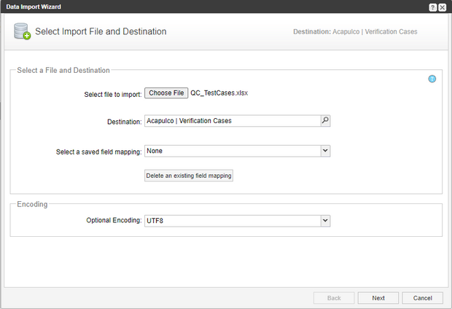

1. Select Excel worksheet Query1. Leave Header Row as 1.

Set “Default Value” and “Mapping” following *Figure 4.3.2*. Click Next.

*Figure 4.3.2 Data Import Wizard-Field Mapping*

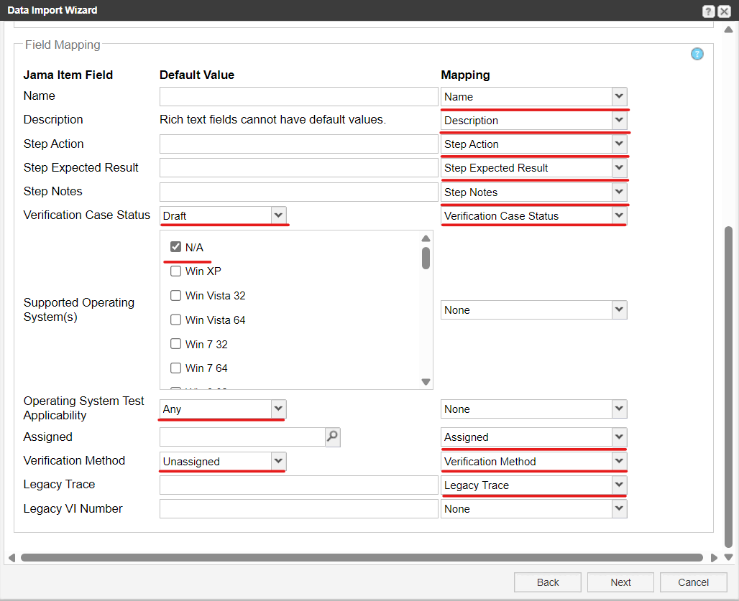

1. Check “Import hierarchy based on indented cell from column” and select “Verification Method” field, and check “Color cells indicate folder or parent item from column” and select “Legacy Trace” following *Figure 4.3.3*. Click Next.

*Figure 4.3.3 Data Import Wizard – Additional Options*

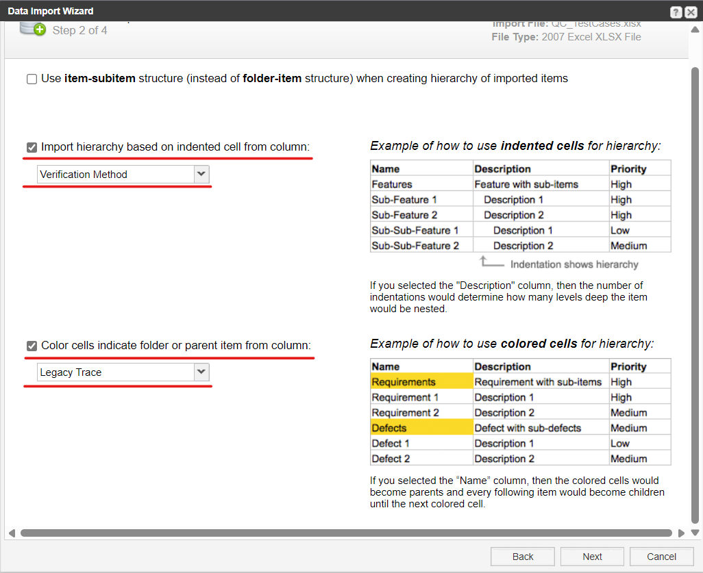

1. Click Submit for finished import.

# 5. Relationship between Design Inputs (DI) and Verification Cases(VER)

## 5.1 Export trace view (.csv) of DI from Jama

Reference to **3.2 Export trace view (.csv) of DI from Jama**

## 5.2 Export trace view (.csv) of VER from Jama

1. Login Jama, enter Verification Cases -> Trace View.
2. Click “Set columns” in “SOURCE ITEMS”. Select *Project ID*, *Global ID*, *Legacy Trace*, and deselect others.

*Figure 5.2: Verification Cases Trace view*

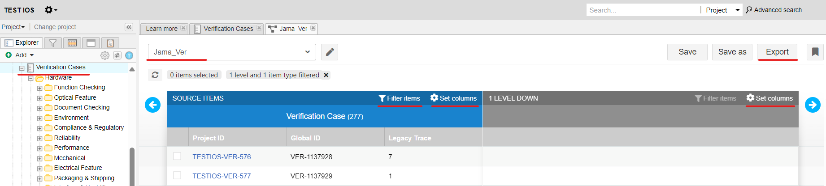

1. Click “Set columns” in “1 LEVEL DOWN”. Deselect all.
2. Click Save. Modify the name of the saved trace view to “Jama_Ver” (*Figure 3.2*). Click Export.
3. The file ***Jama_Ver.csv*** is generated with similar format in *Figure 3.1.3*.

## 5.3 Export Legacy ID trace of DI2VER from QC

Login QC and select domain and project. Enter Analysis View -> Public -> Requirements -> QC_TCTrace. Click Generate(Figure 5.3). The file ***QC_TCTrace.xlsx*** is generated.

*Figure 5.3 generate QC_TCTrace*

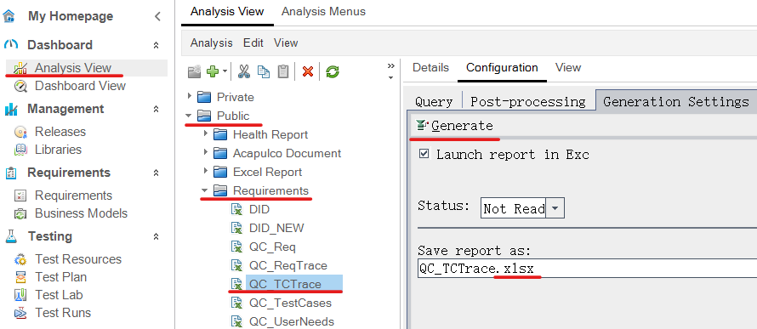

## 5.4 Create Global ID trace of DI2VER

1. Make sure the exported files *QC_TCTrace.xlsx, Jama_**DesignInputRequirements.csv, Jama_Ver.csv* are put to the same path and all closed.
2. Config **DI2VER** section in migrate_Jama_QC.json (*Figure 4.2*). Only need to set correct file path for the argument of *Files_Path*. No need to change other arguments in the file.
3. Run ***4_Jama_Trace_DI2VER.bat*** to generate the files ***Trace_DI2VER_GlobalID.csv*** and ***Trace_DI2VER_Verify.csv***, in which ***Trace_DI2VER_Verify.csv*** is useful for checking internal result with Legacy ID.

*Figure 5.4.1: Generate DI2VER trace by Global ID*

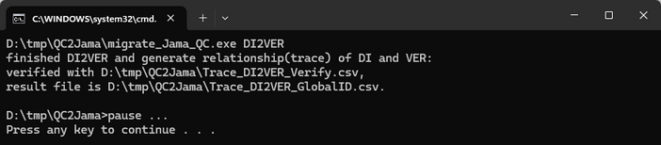 *Figure 5.4.2: Trace_DI2VER_GlobalID.csv*

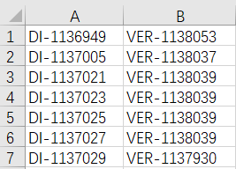

*Figure 5.4: Trace_DI2VER_Verify.csv*

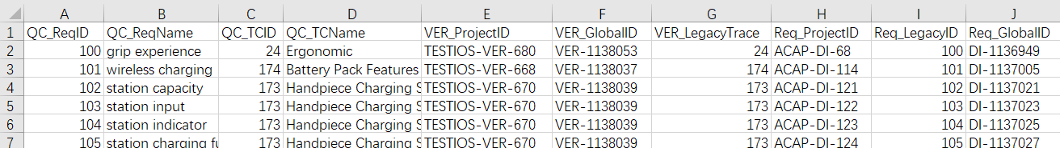

## 5.5 Import trace of DI2VER (by Global ID) to Jama

1. In Jama, select Project->Import->Custom import (*Figure 3.5*).
2. Select a set of Design Input Requirements as destination. Follow *Figure 5.5* to import by Global ID, “**Select Custom Importer:**” need selected “***Import DI-VER (Global IDs)***”.

*Figure 5.5.1 Import DI-VER (Global IDs)*

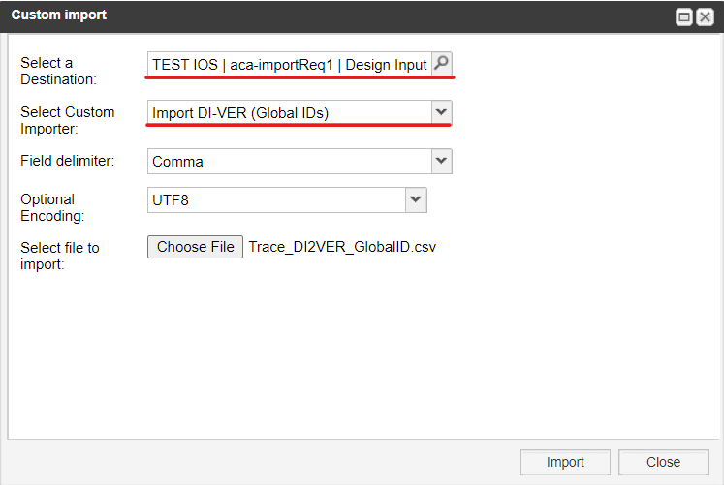

1. Verify the relationship as *Figure 5.5.2*.

*Figure 5.5.2 Verify relationships*

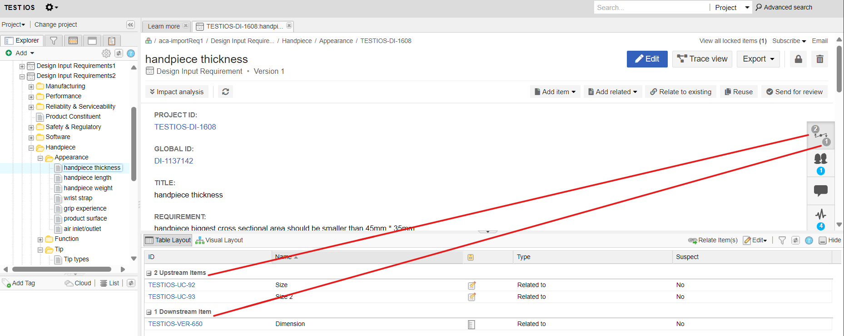

# 6. Appendix: Automation tool used in this document

These batch files (*.bat) are provided to invoke each function designed in migrate_Jama_QC.exe which is powered by Python, and input arguments are set in migrate_Jama_QC.json.

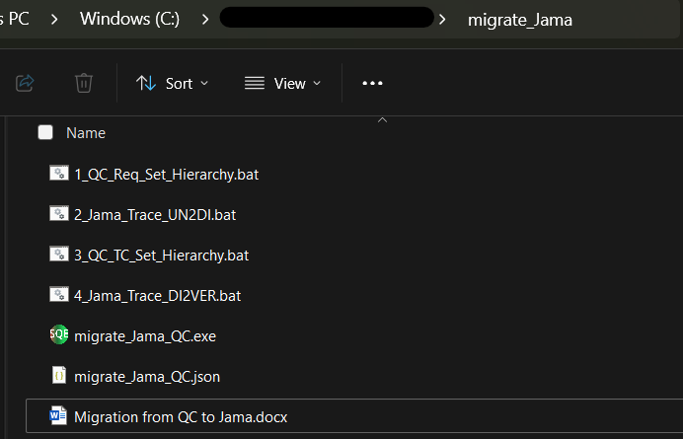

**Note:**

1. The file path shall exclude the characters having special meaning in Python, such as & ^ $.

2. When meet Excel running error message, kill Excel process in Task Manager and then run bat again.